Mechanical Design

I have been searching on the web for how to design XY plotter mechanism. Now there are some basic parts that I have been coming across. Some knowledge related to mechanical parts and their names are required to actually find info about that mechanism.

Linear Bearing

These parts are bearings that can slide along any axis. The part widely available in Bangladesh online shops is named scs25uu or sc25uu

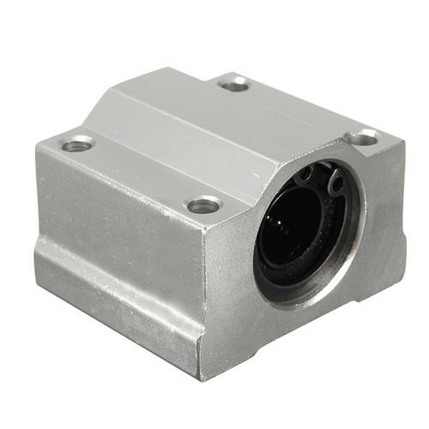

Linear Guide Shaft

Guide shaft is the part that holds the guide rail in place, and the bearing will slide along the rail.

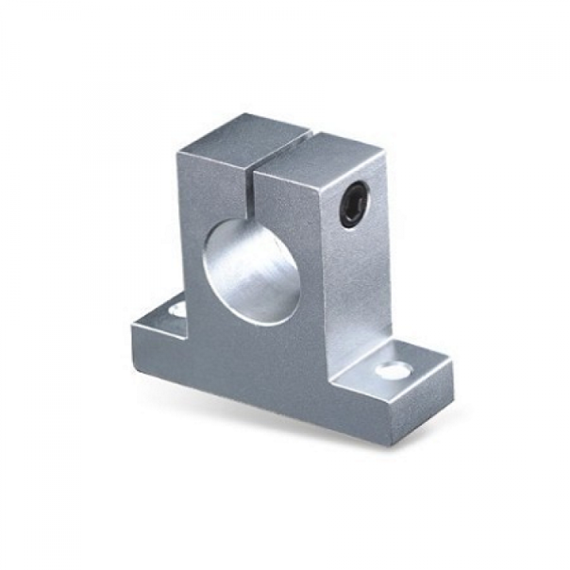

Guide Rail

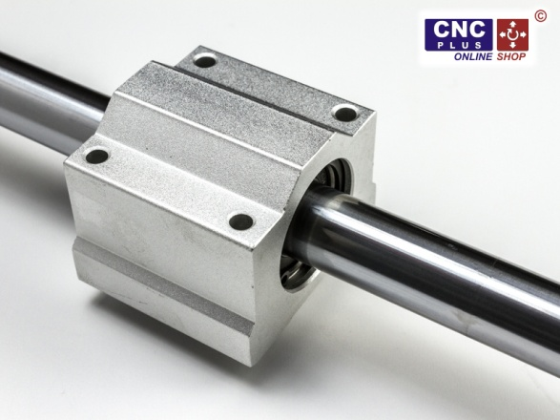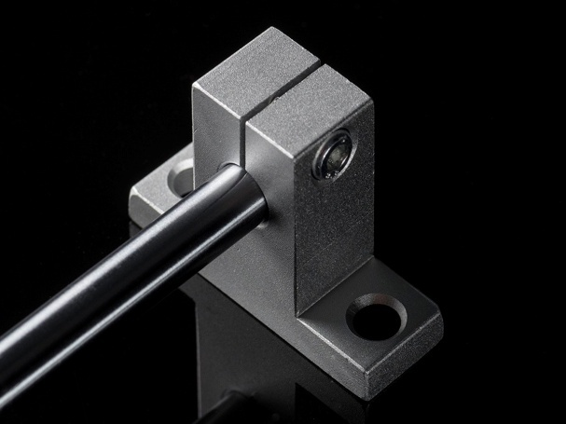

I have come across a website where you can search for parts and download their 3D designs for implementation on your design

[www.traceparts.com](http://www.traceparts.com)

also, there is [www.grabcad.com](http://www.grabcad.com) where makers share their own designs and you can download stuff for your use.

